**CIMA/CGMA Course**

**CIMA is the Chartered Institute of Management Accountants**

**“BE THE BRAINS BEHIND THE BUSINESS”**

It is the world’s largest professional body of chartered global management accountants, and offers the most relevant accounting qualification for a career in business.

In collaboration with the American Institute of CPAs (AICPA®), Chartered Institute of Management Accountants (CIMA®) members receive an additional designation - The Chartered Global Management Accountant (CGMA) and is accepted across 180 countries of the world.

The CIMA programme is a Unique blend of Management Accounting, Financial Accounting &

Business focused subjects produces competent and confident CGMA's who can lead their

organization to sustainable success.

1. **About CIMA – With Icons**
2. 650,000 - Members and students of CIMA and the AICPA
3. 225,000 – Employed Members
4. 179 - Countries and territories where members live
5. 33 - Representative offices around the world
6. 54 - Supported credentials, designations, diplomas and certificates
7. 4 - Premier globally recognised designations — ACMA, FCMA, CGMA and CPA

**You can refer our brochure design –**

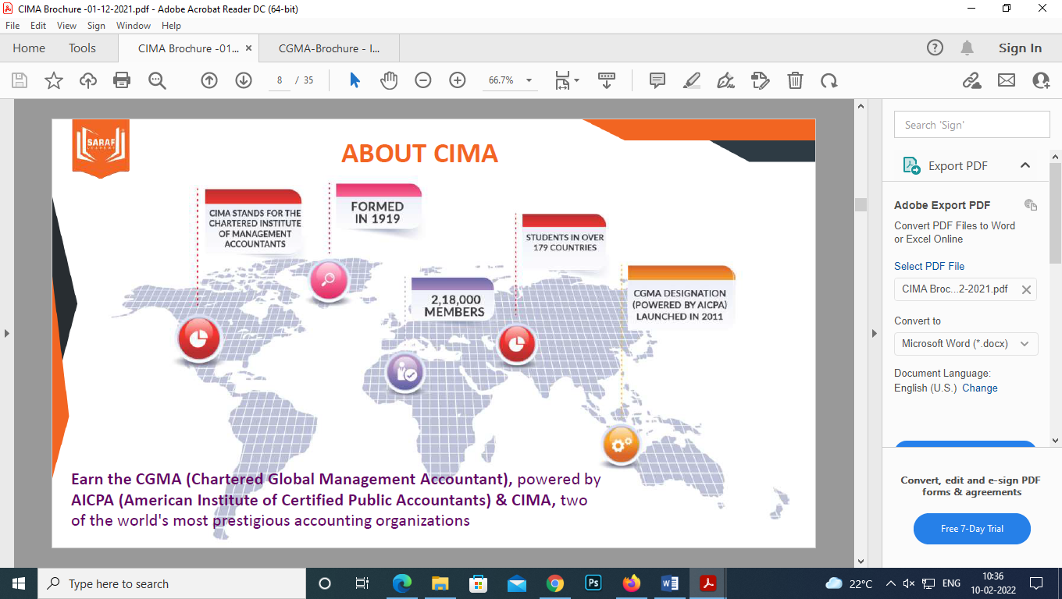

1. **CIMA Advantages – take from our brochure**

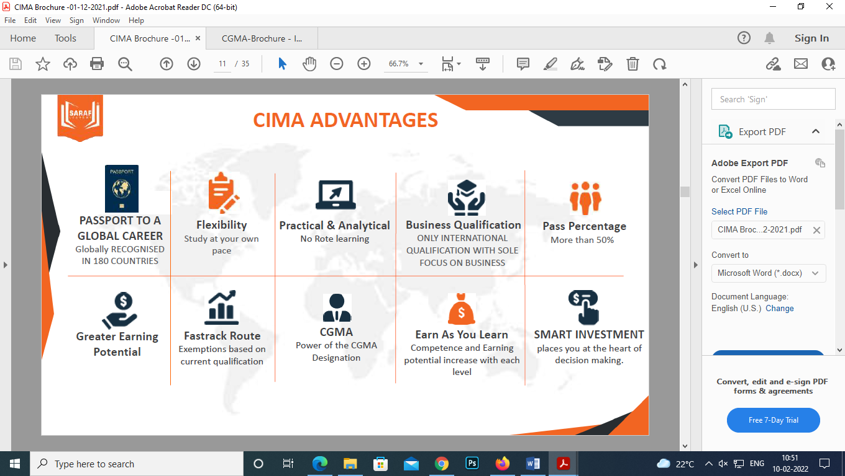

1. **What sets a management accountant apart from a traditional accountant?**

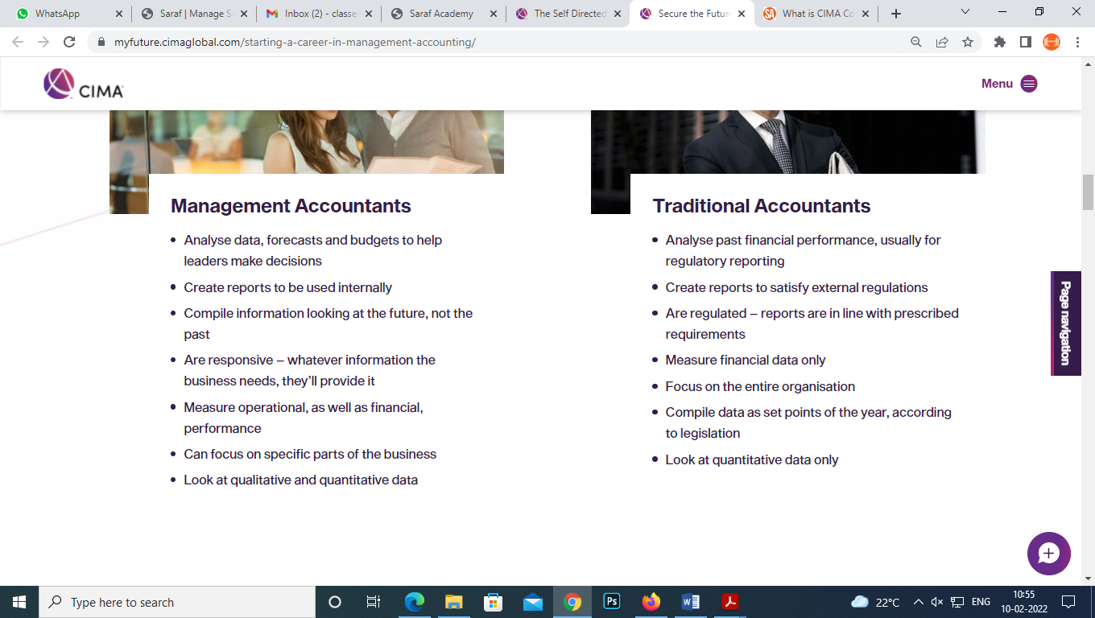

**You can take this content from -** [**https://myfuture.cimaglobal.com/starting-a-career-in-management-accounting/**](https://myfuture.cimaglobal.com/starting-a-career-in-management-accounting/)

1. **CIMA Course Structure – take from our brochure**

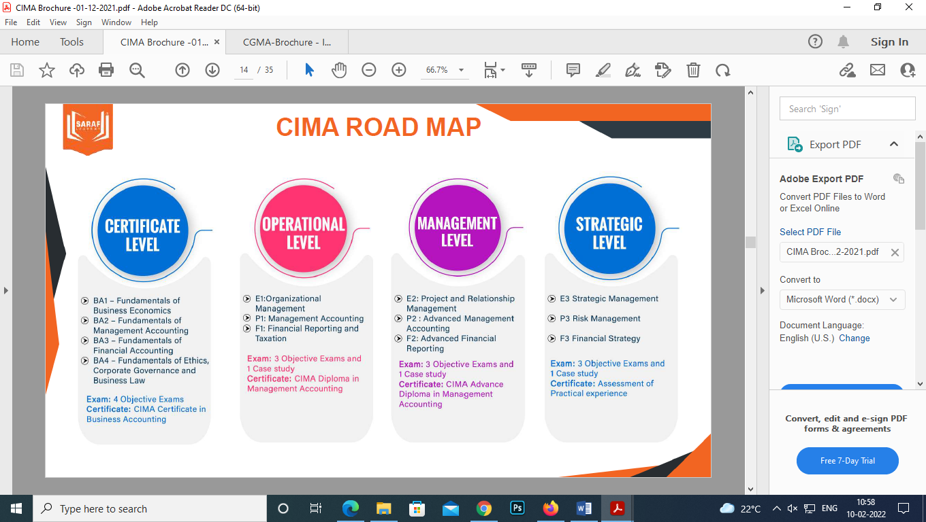

**Based on background the student will enter the program from different route**

1. **What is CGMA Finance Leadership Program - Be the future of finance**

The CGMA designation is the most widely held management accounting designation in the world. The CGMA Finance Leadership Program has been designed to give you the skills, practical experience and forward-thinking, entrepreneurial mindset business needs of their finance professionals. It distinguishes more than 150,000 accounting and finance professionals who have advanced proficiency in finance, operations, strategy and management.

The Finance Leadership Program provides all the necessary skills to prepare for the case study exams to earn your CGMA.

1. **Why CGMA? With Icons(If it can be created in attractive way)**
2. It’s Business, not just Accounting
3. It’s Student Friendly: Maximum of 3 Case Studies Exam (FLP route)
4. It’s a Career: Gives skills that can take you to CFO/CEO level
5. **The CGMA Finance Leadership Program helps you: (It should be in Icon format)**
6. **Personalize your learning journey -** Flexible and Self-Paced
7. **Accelerate career growth -** Become a Strategic Leader
8. **Develop in‑demand skills -** Skills That Matter
9. **Streamline professional development -** Integrated Learning and Assessment
10. **Earn CGMA Designation -** Showcase Your Value

**Reference image:**

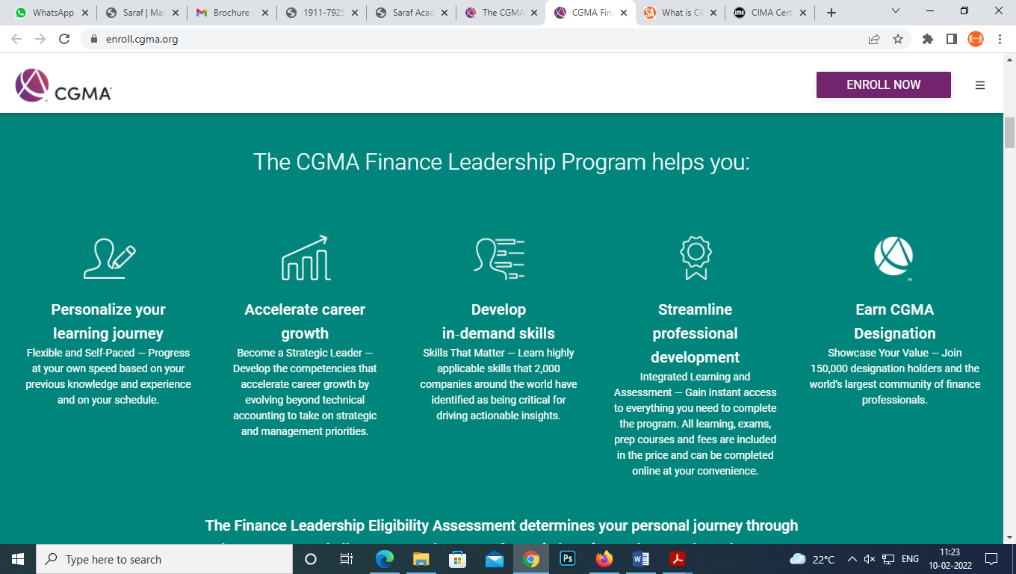

1. **Fast-track career growth - An exclusive pathway for corporate professionals**
2. **Global C-Suite Business and Finance Route**



1. **Global Professional Accountant Programme(GPAP) Route**



1. **CGMA Senior Executive Programme(CSEP) Route**



1. **CGMA Finance Leadership Programme(CGMA FLP) Route**



1. **Key features of the CGMA FLP Curriculum by the CIMA Institute:**

* All learning and assessment materials you need to complete the Professional Qualification which will cover your technical knowledge
* Flexible entry points

• Interactive exercises in CGMA Learning platform

• Business simulation assignments in CGMA Learning platform

• Access to tutor videos about how to approach your Case Study exam

• Video analysis of the pre-seen materials for your Case Study window

• Two graded mock exams with personalized feedback

• One ungraded mock exam

• Ability to skip topics you already know with pre-assessments

1. **Why Us – same**
2. **Top Companies hiring our students – same**
3. **Testimonials**
4. **VINAY MISHRA -** It has been a pleasurable learning experience at Saraf Academy.I joined for CIMA SCS exam here and was amazed by the teaching skills of Prakash Sir.I never found any issue in understanding the concepts in the class as it was very precise and to the point and was explained very professionally. The entire humungous syllabus was divided in small chunks to ensure that it doesn't look very daunting. The support staff has also been very helpful and quick to respond to our queries. Even if I missed any live sessions I did not have any issues whatsoever as the classes were uploaded on time. The most important aspect of Saraf Academy is the kindness of all the staffs including Prakash Sir himself. Thank you Sir for all the help and keep making all parents proud!!
5. **Ateeq Asgar Ali Sayyed -** Mr. Prakash Saraf is a qualified, experienced and dedicated teacher and moreover a good mentor, who has vast business and technical knowledge which helps students to excel in their professional exams with ease.I had an amazing experience with Mr. Prakash as a learning partner of CIMA-UK whilst pursued my strategic case study for November 2020. He helps and supports students to pass their exams in flying colors.I recommend students aspiring to any finance qualifications local or international to pursue coaching with SARAF ACADEMY. Thank you
6. **Jay Choksi** - I appeared for CIMA SCS exams last in 2014 and then never touched books or any material and completely disconnected myself from course. When I thought to restart and upon inquiring with friends, I got reference of Mr Saraf. I was completely after Mr Saraf and asked many questions to bring my fear out and he patiently answered all of them. The learning experience was amazing, he uses practical approach to explain the concepts. Due to job, I barely get time for extra studies, so I only referred his online classes and basic notes and solving mocks regularly. I strongly recommend Saraf Academy for CIMA preparations.
7. **Vijay Kumar** - In my opinion, Saraf sir methods of teaching are the best for CIMA. The way he taught F2 topics for MCS exam is the differentiator for pass and fail. I got 87 in Nov 2020 exam, 77 in August 2020 attempt when I took classes with another institute in UK. I can tell for sure that I would have failed again if I hadn't taken Saraf classes. Because in Nov exam also I got a tough F2 question just as I got in August exam. But after giving Nov exam, I was confident of passing the exam and I got the right result. So, I will continue Strategic level also with Saraf sir. I love listening to Harsha Bhogle, after Harsha somehow I enjoyed listening to Saraf sir. It helped me. This is my honest and genuine feeling
8. **Nimisha Parmar** - It is very good experience and knowledge gain studying CIMA from Prakash Saraf sir. His work experience and knowledge on the subject is tremendous and appreciated. Very supportive and clarify the doubts in a most understanding way.I would definitely recommend studying CIMA from this institution. I was able to clear CIMA management case study with assistance from Prakash Saraf sir. Good luck and keep the good work.
9. **Jasleen Kaur** - I have continuously taken classes for my CIMA exams from Saraf academy and have been successful at clearing them at one go. Prakash Saraf Sir always ensures that every student gets the attention they need and deserve. He always encourages one to work hard to achieve their goals. The staff at the academy is also very helpful and prompt.

**Testimonial Video-**

1. [**https://youtu.be/CWIbjrnW4-8**](https://youtu.be/CWIbjrnW4-8)
2. [**https://youtu.be/JmsXtkfGwFA**](https://youtu.be/JmsXtkfGwFA)
3. [**https://youtu.be/GCQ9TLaI3p8**](https://youtu.be/GCQ9TLaI3p8)
4. [**https://youtu.be/UR3leSWbX0U**](https://youtu.be/UR3leSWbX0U)
5. [**https://youtu.be/OFlc8FR6gBA**](https://youtu.be/OFlc8FR6gBA)
6. **FAQs**
7. **What is FLP?**

The CGMA FLP is a new digital-first pathway to complete the CIMA Professional Qualification. You are assessed at each topic as you learn, all within the FLP platform.

All three levels of the FLP culminate with a Case Study Exam to test your mastery of the business concepts and your ability to apply your knowledge and skills in real-world business situations.

It is the fastest route to CIMA qualification as you have to write a maximum of 3 External Case Study Exams only.

1. **Who can register for the CGMA FLP Program?**

It is for Undergraduates, Commerce Graduates pursuing B.Com, BBA, etc or non-commerce graduates including Engineers and Semi – Qualified & Qualified Professionals

1. **What is the scope of CIMA in India/Abroad?**

CIMA’s scope in India is increasing at a fast pace with job opportunities in Big 4 & MNCs.

CIMA’s scope outside India is immense, be it Middle East, UK or Europe. CIMA students and members are working across 180 countries of the World.

1. **What is the estimated timeline to complete CGMA FLP Program?**

Every path to earn the CGMA designation is unique. The CGMA Finance Leadership Program offers different entry points, so you can start the program at the appropriate point based on your education and experience. Your entry route will determine, in part, how long it takes you to complete the CGMA Finance Leadership Program and earn the CGMA designation.

Most candidates should aim to complete each Level, including both the learning and the Case Study Exams, within 9 – 12 months maximum depending upon their qualification & work experience.

1. **What will I learn by taking CGMA FLP Program?**

You will get to learn Technical Skills, Business Skills, People Skills, Leadership Skills & Digital Skills.